You get to create a Jump Rope For Heart Web Page and YOU will raise more life-saving donations! To get started, Register today and join your School Team. Here’s how…

Step 1: Log in to your Headquarters web page by visiting www.heart.org/jump and click on the words that say ‘Register Now!’

Participant – Register Online for Jump Rope For Heart!


Step 2: In the Search For a Team form, select your school state and city. A list of school names will open.

Step 3: When you find your school, click the Join Team hyperlink.

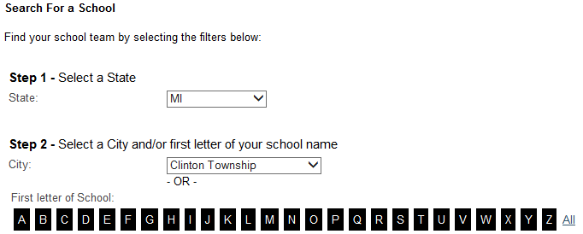
u

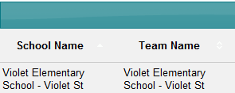
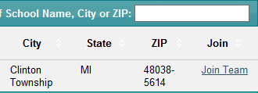



Step 4: Create your own Username and Password and answer a security question. Click Continue. **Be sure your Username and Password are easy to remember. Write them here so you don’t forget:

My Username: __________________________ My Password: __________________________

Step 5: Fill out the registration form. On the bottom of the form there is an Online Waiver. Review the waiver with your parents to click the box to accept it. Once you are done, click the Continue button.

Step 6: A Share With Your Friends screen will pop up. Enter a message that you would like to share via social media and click on the program/s that you would like to use. Once you are done, click the Publish button. (Click the “X” in the upper right hand corner of the pop up box to skip this step.)
*You’ll see a confirmation screen and a button you can click to enter your Headquarters and set up your web page!

Congratulations! You have registered for Jump Rope For Heart online!
Your next step is to email your family and friends using the email tab in your Headquarters. When you receive your first online donation you will receive Scribbles Ninja Duck and when you reach $75 you receive Ms. Cool!

Step 6: A Share with your Friends pop-up box to share on social media will appear. To share, click the check box of the social media icons you use and click Publish. Click the “x” to close the box if you don’t want to share now.

